Coloring Books, Video Recorders, and Sandpaper: Three Cultural Metaphors
Excerpt from Border Crossing: American Interaction with Israelis, by Lucy Shahar & David Kurz

…We described Israel as a cultural mosaic. At first glance, the many pieces in the mosaic or puzzle fail to form a discernible pattern; that is, there doesn't seem to be a single homogeneous Israeli culture. Israel is both Western and Eastern, secular and religious. If one studies the puzzle carefully, however, the pieces do fall into place; there is a discernible pattern. Certain behaviors, norms, and attitudes are widely shared among Israelis and are encouraged; others are discouraged. It is into the nexus of these shared values and behaviors that the culture of Israel can be found, and that is what we mean by the term "Israeli culture." New immigrants pick up the message quite accurately and quite quickly: there are ways of speaking and acting that are "Israeli." If one wants to be included in the society, those ways of speaking and acting must be incorporated into one's repertoire. If one does not take on those attitudes and behaviors, he or she will be "included out." Three images serve as metaphors for those behaviors and attitudes which we believe are recognizably Israeli. The images are: a page from a coloring book, the "fast-forward" mode on a DVD player, and sandpaper.

THE COLORING BOOK
FIGURE 1: Standard Coloring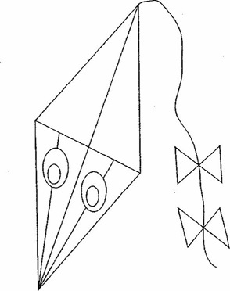 Book Picture | FIGURE 2: American Percept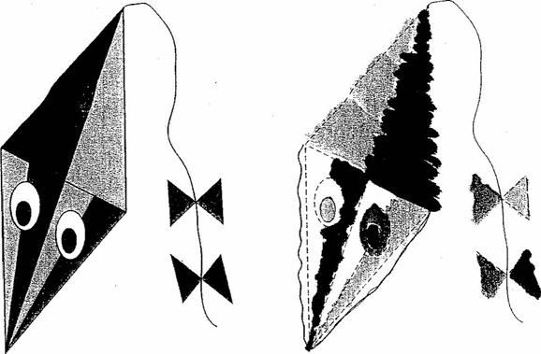ion | FIGURE 3: Israeli Perception

Take a close look at the pictures from the coloring book. Figure 1 is an exact duplication of a page in a children's coloring book. Figures 2 and 3 reflect the perceptions of Americans and Israelis, respectively. "Israelis can't stay within the lines of the coloring book," Americans frequently say. The fact is that Americans and Israelis have different mental images of the same picture in the coloring book. The American mental image of the coloring book often corresponds to Figure 2. In the American picture, all of the lines are solid and clearly defined. In the Israeli picture—Figure 3—the lines themselves are blurred and even indistinct in places. Whoever has worked on the picture has colored outside the lines. The "artist" was not restrained by the borders, but felt free to create something beyond the defined lines and to make it his or her own. On the other hand, the results give the impression of things being a little out of control. The coloring does not seem to be carefully planned or thought out. The whole picture has an unfinished quality. It may turn out to be a charming example of free-form creativity, or simply a mess. The coloring book may be seen as an obstacle to creativity or, from another perspective, as a springboard to improvisation. In the workplace, in particular, the ability to improvise as well as the tendency to do so expresses itself in every area. Israelis cannot be bothered with "doing it by the book." They prefer to take a system apart, to find new or better ways of achieving a goal or solving a problem. Indeed, it is precisely the Israeli capacity for creativity and the ability to improvise which have for many years attracted clients interested in joint ventures in the area of research and development.

Spontaneity: The Israeli communication style is spontaneous, natural, and unrestrained. In the workplace, spontaneity expresses itself in the ability to come up with on-the-spot solutions to problems instead of relying on the book or being limited by it. Staying within the bounds of expected conduct is confining. In a formal meeting, Israeli representatives may offer their views as they come to mind without considering whether they are interrupting, or whether offering an opinion at a particular juncture is appropriate. From an American perspective, that behavior is out of line, that is, aggressive, if not offensive. Spontaneity in the workplace sometimes expresses itself in a tendency to "wing it." It is not unusual, for example, to witness a staff presentation which seems extemporaneous. It is obvious that the presenter is well grounded in the material and that the presentation has substance, but it clearly has not been thought out systematically in advance. ("I don't prepare ahead of time because it is too confining," many Israelis say. In everyday encounters, the inability to stay within the lines is demonstrated literally. Israelis have difficulty waiting in line at banks, movie theaters, health clinics. An Israeli line is amorphous. It is often hard to tell where it begins and where it ends. Sometimes it is even hard to figure out who's in front of whom. Spontaneity expresses itself in social encounters as a lack of inhibition. If you want to invite someone to your home, you do so. If you are interested in how much someone paid for an apartment or dress, you ask. If you are angry, you show it. If you want to give advice, you give it, even if the advice is unsolicited.

Positive Attitude toward Risk Taking: The readiness to color outside the lines means that the individual working on the picture is willing to take a risk. Maybe the picture will be a mess; maybe it won’t. In the workplace this attitude expresses itself in a tendency to try out new approaches even if they have not been carefully thought through. All of this produces many surprises; but again, surprises are accepted as normal in Israeli life. In commercial and bureaucratic encounters, the positive attitude toward risk taking expresses itself in a willingness to test the rules: "It's true that the sign says your office is closed, but I' m going to pretend that it is still open. The worst that can happen is that you’ll say no and try to throw me out, but even that is negotiable." (Americans also possess a positive approach to risk taking, but the quality expresses itself differently in the two cultures).

Self-Confidence: Israelis are confident that going out of the lines will work, and even if it doesn't work, they are self-confident enough to take the risk. But, as some outsiders have noticed, there is a thin line between self-confidence and arrogance. Self-confidence expresses itself in the willingness to improvise, to develop creative solutions for problems in the work environment, to question authority, to make decisions outside the boundaries of one's job description, to risk oneself in a sexual or social encounter. Arrogance expresses itself in a haughty attitude toward those who choose to color inside the lines. The implicit message is: people who stay within the lines of the coloring book (e.g. behave solely according to instructions or established procedures) lack self-confidence, they are rigid, afraid to risk, "square." A combination of informality, spontaneity, a positive attitude toward risk taking, the improvisational approach to problem solving, and self-confidence explains the easygoing Israeli approach toward planning. The outline of the picture in the coloring book is a framework providing shape and structure, but Israelis do not view themselves as limited by frameworks. Indeed, few Israelis would expect anyone to color inside the lines. The framework of the picture is analogous to a plan. Army officers and noncoms are taught to plan. They are taught well. At the same time, they are also taught that a plan is a basis for change. The message is drummed into their heads: "Don't be controlled by your plan. Use it to respond to the situation in front of you. Be flexible! Improvise." Most Israelis in senior positions in virtually every civilian field are veterans of the IDF officer corps. They bring to their civilian positions the style of responding and approach to planning that they learned during their army service. The idea of a plan as a basis for change often finds expression in the workplace. Plans, schedules, and deadlines are viewed as broad guidelines subject to alteration; they are not felt to be binding commitments. (A guideline is simply another line in the drawing.) Leisure-time activities are also affected by the flexible attitude toward plans and planning. A guide in an organized tour may decide to change the plan and alter the itinerary described in the company brochure.

Individualism: Israelis are highly individualistic, as are Americans, but the trait expresses itself differently in the two cultures. The picture in the coloring book helps us understand what individualism means in Israel. One can almost hear the Israeli who colored the picture saying, "No one is going to tell me how to color the picture. I'll do it my way." Israeli individualism expresses itself in a casual attitude toward rules and regulations, a tendency not to follow instructions, and a resistance to imposed authority. ("Do it because I said so.") Israelis usually have to be convinced that a certain goal should be achieved or a given procedure should be adhered to before they agree to follow orders. Individualism also expresses itself in self-reliance: "I don't need to ask for help. I can do it myself," Yet Israel's is also a culture in which individualism exists side by side with strong group attachments. Israelis identify themselves as members of groups, are loyal to group members, and are concerned with the well-being and collective interests of the group (e.g., work teams, friendship circles, ethnic organizations, and army units). Self-reliance is also a strong component of individualism in American culture. Americans believe, as do Israelis, that individuals should be encouraged to solve their own problems and make their own decisions. In other respects, however, the word carries a different meaning. American individualism is expressed in the pursuit of individual rather than common or collective interests. Americans usually view the world from the point of view of the self. One's loyalty is primarily to oneself and one's immediate family, and attachments to groups are relatively loose. American individualism does not appear to conflict with conformity to regulations, going by the rules, or respect for authority. Many people would argue that Israelis are changing as the country becomes less socialistic and more capitalistic and that, as a result, Israeli individualism is gradually coming to resemble American individualism. The differences remain marked, however. Perhaps the easiest way to understand them is to look at how each group sees the other's behavior. Americans look at behavior which Israelis call "Israeli individualism" and label it childishness, insubordination, disrespect, anarchy, and arrogance. Israelis look at behavior which Americans call "American individualism" and label it selfishness or egotism.

Limited Respect for Authority/Casual Attitude toward Rules and Regulations: By definition, authority implies the existence of limits and constraints: clearly defined rules concerning what is permissible and what is not. Respect for authority means that one stays within the lines, observes the rules. In the Israeli coloring book, however, the lines are either hard to discern or subject to testing. In everyday life, behavior in the public parking lot is an example of the casual (some would argue indifferent) Israeli attitude toward rules and regulations as well as evidence of their individualism and their improvisations approach to problem solving (see Figure 4). Indeed, the arrangement of cars in the parking lot reveals a great deal about Israeli attitudes toward boundaries and border crossings. Painted demarcation lines, denoting parking spaces, are identical to those in parking lots in all Western countries. In an Israeli parking lot, however, cars may be parked on the line instead of between the lines; three cars will be crowded into spaces designed for two. Cars may be parked perpendicular to the cars between the lines, or they may be parked on the islands separating the lanes. Cars will not only be parked in ingenious ways, they will also be parked in the space in which the sign clearly proclaims "no parking." (Some people think that the way Israelis park can be explained by the fact that there are too many cars and too few parking lots in Israeli cities. But even when there is plenty of space, the parking-lot picture tends to look the same.) Somehow, Israelis devise ingenious ways of solving their parking problems, even if doing so means that the overall result is extremely disorderly. In fact, one person's solution to the parking problem may in turn create difficulties for other drivers who discover that it is almost impossible to move into or out of a space, or into or out of the parking lot itself. That becomes a problem-solving challenge for those drivers, often leading to a higher order of ingenuity and improvisation. If one has parked in a tow-away zone and been graced with a boot on one's car (Israelis do receive parking tickets for violations and do pay heavy fines), one feels free to argue with the officer in charge, to "step out of line." Consider the following scene: A newcomer to the city is driving on a busy street looking for a place to park. He sees cars parked on the sidewalk or with the side wheels up on the curb. Where he comes from, sidewalks are for pedestrians. Uncertain whether parking on the sidewalk is permissible in Israel, he stops a policeman.
Newcomer: "Is it OK if I park my car on the sidewalk?"
Policeman: "Of course not. It's illegal."
Newcomer: "What about all of these cars?"
Policeman: "Their drivers didn't ask!"

THE FAST-FORWARD MODE ON THE DVD PLAYER:
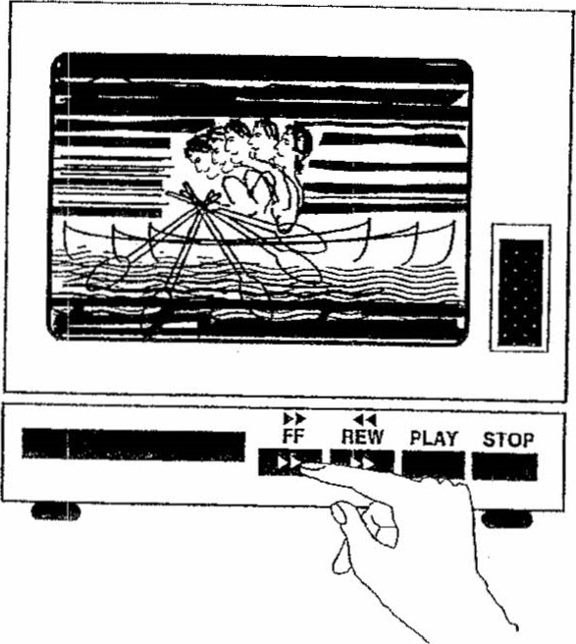

Our second metaphorical image is the fast-forward mode of a DVD player. On "play," everything is as it should be, moving at a normal pace and rhythm. When one presses the fast-forward button, the pictures on the screen flash by in rapid succession. It is difficult for the viewer to keep track of the movements of arms, legs, and "talking heads." All the figures appear to be very animated, like characters in a cartoon. Everything is hurried and nothing stays on the screen for more than a moment. The fast-forward analogy sheds additional light on informality as an Israeli cultural trait. In an informal culture, the transition from stranger to instance occurs at a rapid pace; people get to know each other quickly and feel free to shift into a closer personal relationship at a relatively early point. Since Israeli culture is more informal than American culture, or almost any other, it often seems that Israelis operate on the fast-forward mode while Americans operate on "play." Fast-forward expresses itself in both business and social settings. An Israeli who is a guest or stranger at a formal meeting in the workplace may behave as if he or she has known the other participants for years. This will usually include shifting into a direct mode of communication at a surprisingly early and, from an American point of view, sometimes inappropriate juncture: "Let's forget all these welcoming speeches and get down to work!" In social encounters, distances are bridged quickly. There are few social barriers, and those that exist disintegrate rapidly. Israelis feel uncomfortable standing on ceremony. Small talk, for example, may be short-lived or nonexistent. "Hello. Nice to have you as a guest in our home. How was your trip? So you work for the Atomic Energy Commission. How did you ever allow Three-Mile Island to happen?" From the American perspective, all of this occurs in fast-forward.

SANDPAPER
Our third metaphor—visual, aural, and tactile—is sandpaper. Sandpaper is rough. When two pieces of sandpaper are rubbed together, they cause friction. The sound may be grating, jarring, irritating. If sandpaper gets rubbed on skin, it hurts. But used to smooth out rough surfaces and paper [it] is an essential tool for every carpenter, professional or amateur. It gets the job done. Of course, sandpaper comes in grades, from extra-rough to extra-fine.

Direct Israeli Communication Style: The direct Israeli communication style, verbal and nonverbal, is analogous to sandpaper. It is often rough, grating, devoid of a smooth finish. To a considerable extent, Israel retains the unpolished communication style of the frontier. In its extra-rough mode, this style is aggressive; in its extra-fine mode, it is simple and straightforward. Consider the following scenes:

- You are in a crowded shopping mall. People jostle, push, and bump. There is a great deal of physical contact. The friction of contact in passing is considered normal and does not call for an 'excuse me."
- You are conducting a workshop. The Israeli participants tell you that they want feedback on their presentations. Translation: "Never mind the compliments. Lay on the criticism and forget the frills.'
- You've just presented your point of view on an important and controversial issue. As an American, chances are that you expect to hear disagreement in the form of: "Excuse me, I have a problem with what you've just said." In Israel you are likely to hear, "You're wrong!"

These experiences are upsetting to the uninitiated. They grate on the senses, rub against the grain. Sandpaper is rough. The opposite of rough, or coarse, is smooth. In more formal cultures, high priority is given to teaching children manners—the norms of acceptable speech and behavior. These are viewed as the lubricating niceties that facilitate social interactions. "Lucy, Lucy, if you're able, take your elbows off the table." By the age of seven, children have learned the magic words: please, thank you, excuse me and such basic formulas as "Mom, this is my friend David. David, I would like you to meet my mom." Many Americans are convinced that Israelis never say please, thank you, or excuse me. The truth is that Israelis do use these polite forms. They are employed much less frequently, however; and Americans, who are accustomed to using and hearing a greater number of them, come away convinced that the words have not been uttered at all! In many cultures, this kind of rough behavior is avoided at all costs. Filipinos, for instance, place an overriding importance on what is universally called ''smooth interpersonal relations." In informal Israel, "smooth" is often suspect. It is equated with being artificial, insincere, and hypocritical. Rough is real; it is honest, authentic. Rough hurts, but in Israel, it is assumed that you are able to "dish it out and take it too." Rough works. Americans will frequently use the phrase: "I'm going to tell you the unvarnished truth" when they are about to communicate something potentially painful. Most do-it-yourselfers know that varnish is put on wood that has already been sandpapered. Wood that is unvarnished is simply unpolished. The American unvarnished truth is considerably smoother than Israeli truth is delivered sandpaper style. If asked (and they have been), Israelis overwhelmingly express preference for directness, however painful, over indirection—messages padded for politeness' sake. The direct, confrontational, no-frills style is known as "dugri talk" in Israeli slang. The word dugri comes from the Arabic where it has a similar, but not identical meaning. The dugri style of speaking characterizes sabra communication style. Part of being an Israeli is "speaking dugri." Dugri, in the minds of many Israelis, is contrasted with more diplomatic, less direct, less confrontational communication styles, which are often perceived by Israelis as insincere and artificial. Dugri speech, on the other hand, is equated with sincerity and integrity.

